OFFICIAL COORDINATION REQUEST FOR
NON-ROUTINE OPERATIONS AND MAINTENANCE

COORDINATION TITLE- 23BON002 ITS End Gate Installation
COORDINATION DATE- 12 January 2023
PROJECT- Bonneville Lock and Dam Powerhouse 1
RESPONSE DATE- 26 January 2023

Description of the problem – originally coordinated in MOC 22BON095.

The ice and trash sluiceway (ITS) at Bonneville’s Powerhouse 1 (PH1) experienced a south end gate failure on 30 December 2018. The gate cables were frayed, and the guide wheels were either sheared off or damaged. The gate was removed for repairs, the gate guide slot was plated over, and the ITS returned to service until repairs could be completed and the gate reinstalled. The end gate allows the project to close the sluiceway in the event of an emergency and to float large woody debris free of the channel when it becomes at fish passage obstacle.

Bonneville is scheduled to receive the new gate at the end of March 2023 and is planning to start install in the beginning of October 2023. Bonneville would like to start installing bulkheads the week of October 2nd Water up is scheduled for October 23rd

Type of outage required – ITS OOS (Out of service)

Impact on facility operation – Outage is not expected to hinder powerhouse or spillway operations

Dates of impacts/repairs October 2nd start dewatering process – work through October 23rd

Length of time for repairs ~ 1 month

Analysis of potential impacts to fish

Expected impacts on fish passage –There would be no downstream surface passage route at PH1 for the duration of the work and reduced attraction flow in the tailrace. Without pull from the ITS, fewer juveniles than normal are expected to make their way into the PH1 forebay. Juvenile fish that do make their way into the PH1 forebay could be delayed in passage and thus exposed to higher predation levels. All fishway entrances will remain open and continue to be provided attraction flow except for PH1 South entrance. This may cause adult fish that travel the south entrance of PH1 to be exposed to higher level of sea lion predation. Adult fish that use routes other than PH1 fishway entrances (PH2) are not expected to experience higher levels of sea lion predation

Bon will communicate with Reservoir Control Center (RCC) about fluctuating forebay levels during the work period. A teletype will be required to control the forebay levels during the work window.

- 10-year average passage by run during the period of impact for adults and juvenile listed species, as appropriate for the proposed action and time of year;
The 10-year average for all adult and juvenile species shows an expected 0% to near 0% impact during the work period projected.

Table 1: 10-Year average for work period 10/2 – 10/23
Date | 10/2 – 10/23 10-year avg | 10 Year avg total run | Percent Run Affected
Chinook | 37,802 | 817,285 | 4.6%‬‬
Steelhead | 6,864 | 173,873 | 3.9%
Coho | 23,067 | 113,422 | 20%
Lamprey | 38 | 35,458 | <.01%

- Statement about the current year’s run (e.g., higher or lower than 10-year average);
This work is unlikely to impact any major fish runs in this current year. All fish entrances will still be operational and all but PH1 south fishway entrance will be provided attraction flow.
- Estimated exposure to impact by species and age class (i.e., number or percentage of run exposed to an impact by the action);

During this work window >95% of juvenile Chinook, Steelhead, Coho, and Sockeye passage will have already occurred based on 25-year historical data. Figure 1 and Figure 2 represent yearling, and sub-yearling Chinook passage.
Please see “Expected impacts on fish passage”, Table 1, and Figure 1.
- Type of impact by species and age class (increased delay, exposure to predation, exposure to a route of higher injury/mortality rate, exposure to higher TDG, etc.);
There will be no downstream surface passage route at PH1 for the duration of the work and reduced attraction flow in the tailrace. Without pull from the ITS, fewer juveniles than normal are expected to make their way into the PH1 forebay. Juvenile fish that do make their way into the PH1 forebay could be delayed in passage and thus exposed to higher predation levels. Adult fish that use routes other than PH1 fishway entrances (PH2) are not expected to experience higher levels of sea lion predation
Summary statement - expected impacts on:
Downstream migrants (including Lamprey) -- Downstream passage through the ITS will not be available from 02 October -23 October.
According to the historic 25-year average passage indexes for sub-yearling Chinook at Bonneville Dam (1998-2022), 95% of the run has passed by 10/2 – 10/23 (DART). With the outage occurring in October, the proportion of the run impacted should theoretically be <5%. The last juvenile salmonids out-migrating generally takes place in late October according to DART. (Figure 1, Figure 2).
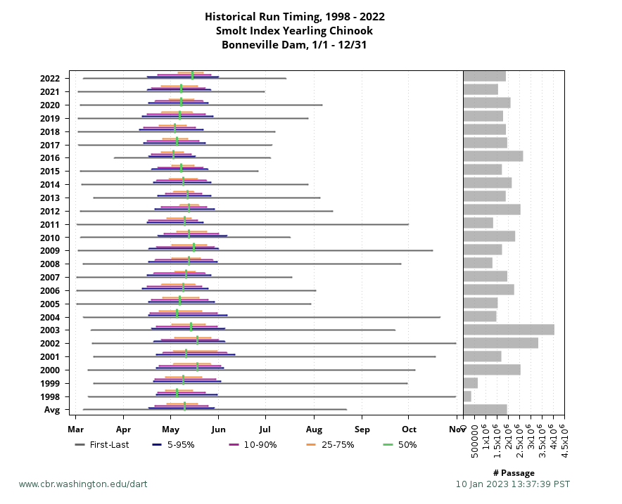
Fig. 1. Historical Run Timing for Yearling Chinook Smolt Index

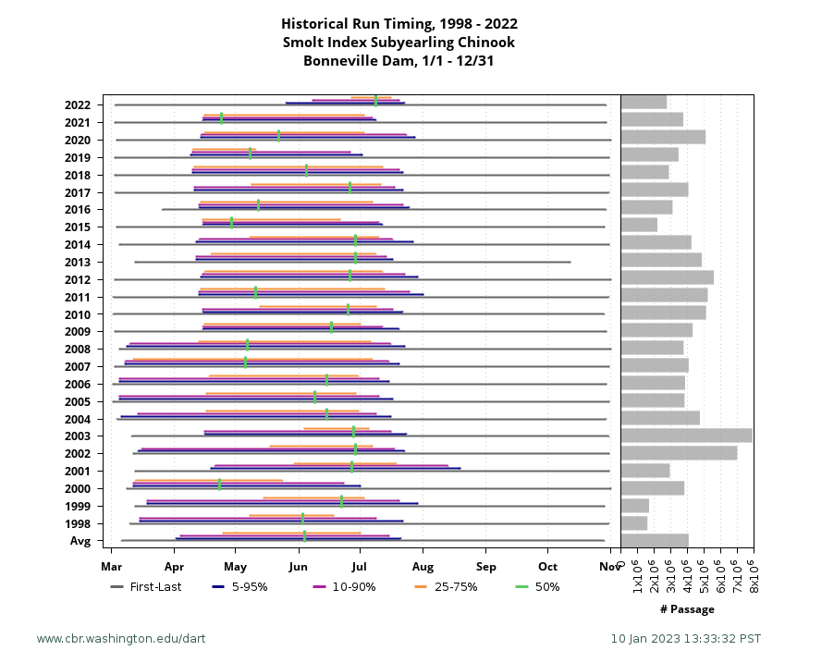
Fig. 2. Historical Run Timing for Subyearling Chinook Smolt Index

Upstream migrants (including Bull Trout) – The upstream and downstream entrances of the Powerhouse 1 Collection Channel (PH1CC) will remain open during the ITS closure. With the loss of attraction flow, some of the fish that would normally be attracted to PH1 passage routes will instead be attracted to PH2 routes. The Sea Lion predation rate is thought to be similar between tailraces, so no increase predation is expected for fish that use routes other than PH.

Lamprey This outage will occur after the end of the adult lamprey migration period. All ladder entrances and LPS systems will not be operating at the time of the ITS outage.

Comments from agencies:

Final coordination results:

Please email or call with questions or concerns.
Thank you,
Tammy Mackey
Columbia River Coordinator
503-961-5733
Tammy.m.mackey@usace.army.mil

